Week 3
write a node js program to perform read write and other operations on a file
fileoperations.js

// Import the 'fs' module
const fs = require('fs');

// Write data to a new file
fs.writeFile('example.txt', 'This is the first line.\n', (err) => {
if (err) throw err;
console.log('File created and data written.');

// Read the file
fs.readFile('example.txt', 'utf8', (err, data) => {
if (err) throw err;
console.log('File content after writing:');
console.log(data);

// Append more data to the file
fs.appendFile('example.txt', 'This is an appended line.\n', (err) => {
if (err) throw err;
console.log('Data appended to file.');

// Read the file again
fs.readFile('example.txt', 'utf8', (err, updatedData) => {
if (err) throw err;
console.log('File content after appending:');
console.log(updatedData);

// Delete the file
fs.unlink('example.txt', (err) => {
if (err) throw err;
console.log('File deleted successfully.');
});
});
});
});
});

Output:
Node fileoperations.js
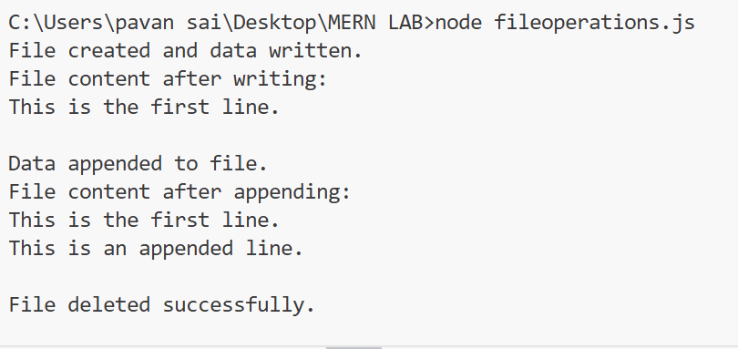

Understanding the code
- const fs = require('fs');
  - Imports the fs module to work with the file system.
- fs.writeFile()
  - Creates a new file called example.txt and writes the initial content.
- fs.readFile()
  - Reads and displays the content of the file.
- fs.appendFile()
  - Appends more text to the existing file without deleting the old content.
- Second fs.readFile()
  - Reads the file again to show the updated content.
- fs.unlink()
  - Deletes the file after the operations are done.

Viva Questions
- What is the fs module in Node.js?
- How do you import the fs module?
- Which method is used to create or overwrite a file in Node.js?
fs.writeFile(filename, data, callback)
- How do you read the contents of a file?
fs.readFile(filename, encoding, callback)
- How can you append data to an existing file?
- How do you delete a file in Node.js?
- What is the use of the callback function in fs methods?
- What does utf8 mean in file operations?
- What is the difference between writeFile() and appendFile()?
- What happens if there is an error during file operation?

